The past perfect

The past perfect tense is formed by the auxiliary verb had + the verb in 3rd form.

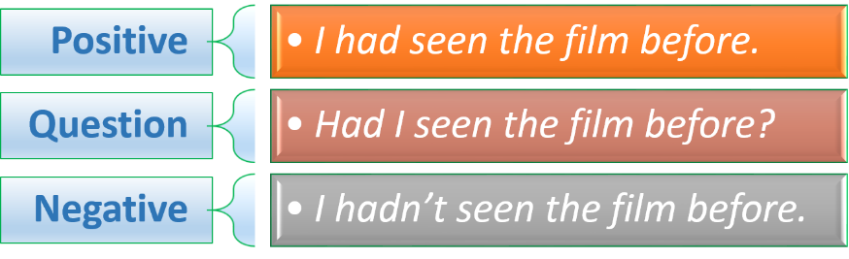

The past perfect shows an action which happened before another action in the past.

*When I got home they had already had dinner. – first they had dinner then I got home.*

The auxiliary verb **had** is the same for all persons. The reducted form of the auxiliary **had** is “**‘d**” e.g. *He’d gone, I’d lived* etc. These forms must not be confused with the short form of **would** e.g. *He’d go; I’d live.*